Boysen Ch 3-4 NPN Transistor Quiz
28jul24 BR

Quiz Instructions
Mini-quiz testing your knowledge of transistors in linear and saturated states. Questions are based on this circuit, hfe = beta = 100. Assume Vbe = .6V when the transistor is on, and the blue LED has Vf=2V.
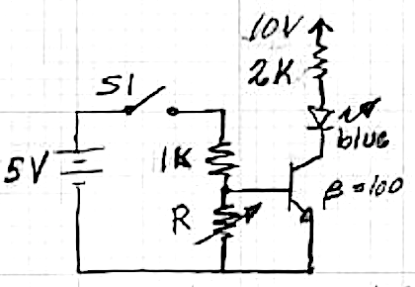
Note: this is a timed quiz. You may check the remaining time you have at any point while taking the quiz by pressing the keyboard combination SHIFT, ALT, and T...

Question 1
R = 10k, S1 is open, what is VR, the voltage across R, in volts?

Question 2
R = 10k, S1 is now closed, what is VR, the voltage across R, in volts?

Question 3
R = 10k, S1 is open, what is the LED current in mA?

Question 4
R = 10k, S1 is closed, what is the LED current in mA?

Question 5
With S1 closed, as R changes from 1kohm down to 150ohms, the LED will:
- brighten
- dim
- turn off
- stay the same brightness

Question 6
Recall the 4 single transistor circuits Rasnow highlighted. This circuit is a(n):
- amplifier
- current source
- follower
- switch

Solutions
- S1 is open VR= 0
- VR = 5*10//11 > .6 0.6V
- 0
- I1k= (5-.6)/1k = 4.4.mA, iR = .6V/10k = .06mA, so βIb = 440mA, saturation = (10-2)V/2k =4mA 4mA.
- iR = .6V/150 = 4mA, so βIb = 100*.4 = 40mA, still saturated no change (D)
- D

